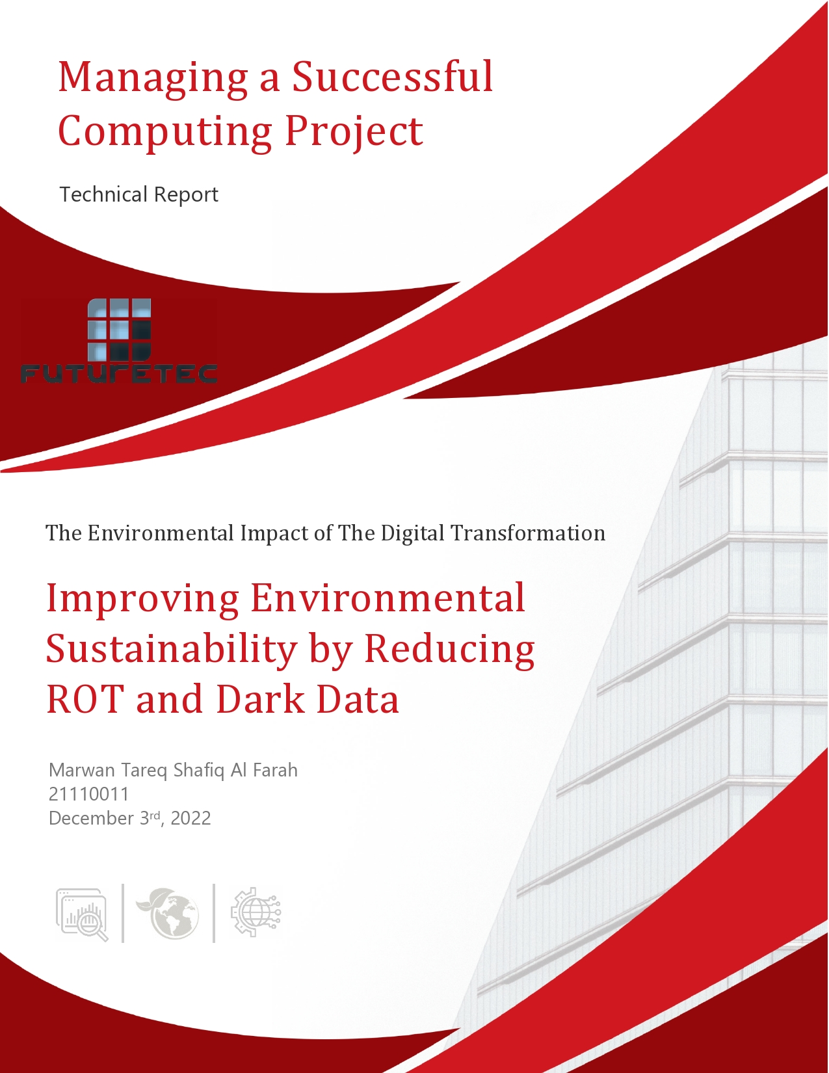

**Table of Contents**

***Introduction*** 3

***Research Study*** 5

**The Idea of The Project** 5

**The Tools and Research Methods that were used** 5

**The Sampling Method** 6

**Primary Data Analysis** 6

**Secondary Data Analysis** ………………………………………………………………………………………………………………. 13

**Conclusions Based on the Analysis** 14

**How the Research Theme Supports the Business Requirement** 14

***Organizational Study*** 15

**The Features of the Organization** 15

**The Operational Areas of the Organization** 15

- **Human Resources (HR)** 15

- **Marketing** 15

- **Customer Service** 16

**How do the Features and Operational Areas of the Organization Support its Purpose?** 16

**Stakeholders** 16

**The Role of Internal Stakeholders** 16

- **Employees** 17

- **Mangers** 17

- **Shareholders** 17

**The Role of External Stakeholders** 17

- **Suppliers** 17

- **Customers** 17

- **Government Agencies** 17

- **Communities** 18

**The Impact of Internal and External Stakeholders on the Success of the Organization** 18

**Challenges to the Success of the Organization** 18

- **Legislation and industry standards relevant to FutureTEC** 18

- **Change Management** 19

**Organization Requirements** 21

***References*** 22

# ***Introduction***

With the turn of the 21st century, the evolution of digital devices skyrocketed with breakthroughs happening in every sector of the market, from education, to banking, to government institutions and NGOs, and especially in the field of computer and data-based companies. Most of society now is reliant on technology to run its business, and make the economy move, and as such digital devices are now pivotal in the running of the economy. This is what is called Digital Transformation.

Digital transformation is the integration of digital technologies into the strategies, processes, and products of an organization in order to adapt to changing market and consumer demands (Whatfix, 2021). Both how organizations operate and how customers engage with them have undergone radical change as a result of digital transformation. Because they can now buy products and services with a single click on their phone, customers are more satisfied than before, which improved their experience with the brand tremendously, as well as increasing the company’s sales and profits. Additionally, data-based insights are now possible for organizations thanks to digital transformation, which means that companies will be able to gather and analyze data to produce insights that can be used to generate money (Thales, 2022).

However, hand in hand with this massive transformation into a digital society, we face a great environmental challenge, Climate Change. Digital technologies and climate change are unquestionably two of our civilization's most distinguishing characteristics, and even though climate change started happening long before the switch to a digital society, and although this digital transformation is not the sole reason behind climate change, it is without a doubt having an impact on the climate situation, whether positively or negatively (UNEP, 2022).

Some of the positives of digital transformation on climate change include using less paper. Whether it was part of government bureaucracy, part of the operation for a company, or as a normal part of operation at universities, we have without a doubt seen a significant decline in the use of paper in all our institutions. This is because the digital transformation facilitates communication more easily and efficiently, it is more capable of delivering information, and getting the job done quicker than paper. As a result of the turn to using digital devices rather than paper, we have seen a decline in the use of toner ink that was required to be used when printing a paper, as it is no longer required at such high demand. This has resulted in saving energy, whether it was electricity that was required in printing a paper, or human energy that was required in printing and delivering the paper to its destination. The most direct result of using less paper is the cutting of fewer trees that were being used to make paper (ACT, 2022).

Another positive result of digital transformation is using less office space. Whether it was working from home, or having more jobs done by computers, office space is becoming less and less important due to the digital transformation. During the *Covid-19* lockdowns, working from home has become the center point of the global economy, as most businesses, learning institutions, and jobs that could work from home started working from home. Even businesses that thought it was impossible for them to work from home managed, and some even excelled at remote working. This has shown to many business owners that offices and office space is not as important as they thought it was, and as a result some have decided to cut down on using their offices. This is good for the environment because workplaces consume a lot of electricity to function, especially when it comes to controlling the office's temperature, which significantly raises the energy cost. As less employees are working in offices, less electricity is being required to operate a smaller office space than what was being used. Furthermore, as less employees are commuting to their work, less cars are being used. These factors result in reducing the emission of greenhouse gases, whether it was in burning fossil fuels to generate electricity, or the use of petrol in running the car, which positively impacts climate change, and this was all facilitated by the digital transformation of the economy.

On the other hand, this shift can have detrimental impacts on the environment if not treated with extreme caution. Some of the negative impacts of the digital transformation include: The massive production of digital devices and the disposal of them. As digital technology is evolving at such a high pace, more and more devices are becoming outdated, and as a result they get replaced at a fast pace. The production of digital device has a direct negative impact on the environment from the extraction of raw materials to assembling them and distributing them to the end user, and after finishing the lifecycle of the device, disposing of them, especially from improper collection, recycling, and disposal. Furthermore, the operation of the digital devices has a direct negative result due to the electricity used to run the device (Truong, 2022).

Moreover, another negative result is the massive amount of data being collected. Many companies nowadays have their whole business model based upon collecting and storing data in their servers. Running these servers consumes a huge amount of electricity as these servers store a lot of data that requires more processing power, which in turn requires more energy to operate. An indirect result is that these servers emit a lot of heat which can ruin the servers and puts the data stored in them in jeopardy, which results in using a lot of cooling systems that consumes even more electricity. Furthermore, as most businesses are shifting toward cloud computing, which requires servers to operate, this problem is exacerbated even more, and some are dubbing this problem as the internet’s hidden carbon footprint. As a result of using the internet for storing data in cloud computing, the Internet would rank as the sixth-largest polluter in the world if it were a nation (Thew, 2020).

What can we do to lessen the negative effects that the digital transformation is having on the environment? One possible answer is to repurpose and use our outdated electronic devices for tasks that require less computing power than they were designed for. For instance, we could download an app like Alfred, which allows you to remotely monitor your home from your current phone or the Internet and utilize our old smartphone that we were about to toss away as an internal security camera. The tablet is another device that can be reused; due to its large screen, it can be used as a digital photo frame that holds and displays all your images. We can accomplish this by looping over the photos in an album using the Google Photos app for Android users or the Apple's Photos app for Apple users (Velazco, 2021).

Future Technology Systems Company - FutureTEC, which is a top provider of information technology solutions located in Jordan, Kuwait, and Bahrain, requested us to prepare and oversee a new project inside their organization that explored ways to refurbish, reuse, or repair digital devices rather than replacing them in order to reduce the company's negative environmental effect as a result of its digital transformation.

# ***Research Study***

## **The Idea of The Project**

The main goal for this project is to reduce the negative environmental impact of digital transformation, by refurbishing, repairing, and reusing digital devices rather than replacing them. Reducing the quantity of Dark and ROT Data stored in datacenters is one way to tackle this problem.

**Dark Data:** it refers to data that firms collect, process, and retain during normal business operations but rarely use for other purposes while keeping it, nevertheless. (Gartner Glossary, 2021)

ROT Data refers to Redundant, Obsolete, or Trivial Data: (Robinson, 2021)

* **Redundant:** it refers to data that has multiple duplicate copies of it kept in various locations on the same system, or possibly on a separate system altogether.
* **Obsolete:** it refers to data that is outdated or no longer in use that might have been replace by new information.
* **Trivial:** it refers to data that the company is not using and that could be easily deleted without having any negative effects on business operations.

The demand for hundreds, thousand, or even tens of thousands of servers can be greatly reduced and require much fewer servers to be able to do the same activities by lowering the amount of Dark and ROT data held in datacenters. By doing so we can significantly reduce the amount of energy that these datacenters consume whether it is for cooling the servers or running them.

The plan is to reduce the Dark and ROT data to the point where many servers will become available and no longer be needed. This can be accomplished by utilizing tools like Aparavi's intelligent data management platform, which enables you to scan and classify all of your enterprise's data in order to locate, relocate, or delete both Dark and ROT data from your firm (Aparavi, 2022). As a result, the servers that are no longer needed can be kept in the facility's storage rooms for potential use in the future. When needed, we refurbish these servers using modern cutting-edge technology and repair any broken parts before bringing them back into service. After that, any e-waste created during the process of repairing and refurbishing these servers, will be recycled rather than being thrown out, thus reducing our overall amount of e-waste.

Meanwhile, the company can update its systems with new data retention guidelines. Every new piece of data that will be kept in the datacenter needs to be marked with the duration for which it will be required, such as "One Week", "One Month", "One Year", "Five Years", or "Forever". Similar to how security cameras record video for a predetermined amount of time before deleting it, the data will be automatically deleted after that time period has passed.

**The Tools and Research Methods that were used**For this study, I made the decision to use an online survey created with Google Forms to gather the primary data on which I will base my analysis. The purpose of this survey is to measure public knowledge of how the digital transformation is affecting the environment. The Mixed-Method methodology, which combines the best components of both qualitative and quantitative methodologies to integrate viewpoints and create a rich picture, enabled me to use this tool to collect both quantitative data (using closed-ended questions) and qualitative data (using open-ended questions). While qualitative data, which focuses on words and textual data, helps in understanding people's perspectives about specific themes, quantitative data, which focuses on numerical data and measurements, assists in assessing the relationship between two variables or in testing a set of hypotheses. Also, I decided against conducting any interviews because I was able to gather the essential information, I required by using online surveys, also, since FutureTEC is not permitted to disclose any information about their datacenters because they do not own the data that is kept there.  
To go to the online survey [click here](https://forms.gle/D28Y3p1922ZG2EpW7).

**The Sampling Method**The population of interest for this study was Jordanian IT firms with either a datacenter or firms that have their entire business on the cloud. The non-probability convenience sampling method was the method I chose to select a sample of the population. Therefore, the sample of the population for the study was FutureTEC, which is the company that had already requested that we complete the project within their own organization, along with its partners.

After that, I used the non-probability snowball sampling method along with the non-probability voluntary response sampling method to choose my sample for the study as it would be hard to reach the entire workforce of FutureTEC along with its partners. It was simple to get in touch with FutureTEC but difficult to get in touch with their clients, therefore I used the snowball sampling method and asked FutureTEC to send the survey to some of their partners who have their data on the "Joud Cloud" of FutureTEC. Also, the FutureTEC staff was sent the online survey through email, and as completion of the survey was not required, the voluntary response method was utilized.

**Primary Data Analysis**  
Firstly, the survey begins with a brief introduction outlining the effects of digital transformation on the environment along with some important details about the survey.

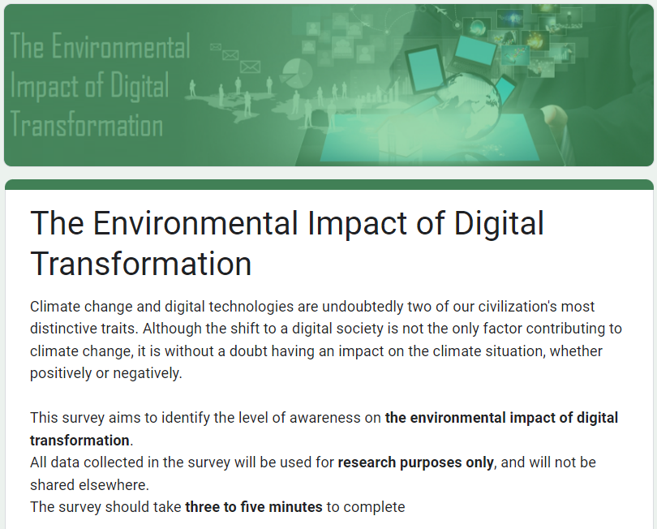

Secondly, the survey starts collecting some quantitative data by asking some general closed-ended questions about the gender, age, and educational level of the individual.



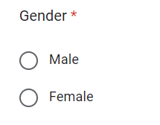

As we can see from the data above, men provided roughly two-thirds of the 11 responses (7 responses), whilst women provided one-third of them (4 responses). Regarding the age distribution, no responses were submitted by people over the age of 55, while 2 responses came from people between the ages of 18 and 24, 5 responses came from people between the ages of 25 and 34, 3 responses came from people between the ages of 35 and 44, and 1 response came from a person between the ages of 45 and 54. Concerning education levels, no responses were provided by people who listed a high school degree, a diploma, or a PhD as their highest level of education, while the majority of respondents (8 responses) appeared to hold bachelor's degrees. In addition, 1 was an undergraduate, and 2 have a master's degrees. None of the respondents used the "Other" option, which was intended to allow qualitative data to be submitted if a person had a degree other than those specified in the educational level enquiry.

Additional general questions included ones about the name of the organization and the position in the organization, the answers to which were provided in the form of short answers (open-ended questions) rather than multiple choice responses (closed-ended questions), allowing us to gather qualitative data.

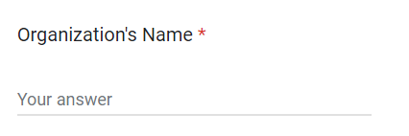

As we can see above, the majority of responses (6 responses) came from FutureTEC employees. Other responses came from some of their partners, including Microsoft (2 responses), Lenovo (1 response), Aramex (1 response), and OPTIMIZA (1 response). Since the question was optional, we were only able to gather 8 replies for the organizational position. All the positions are listed in the chart above.

In the next section, a question about whether the responder is aware of the environmental impacts of the digital transformation appears.

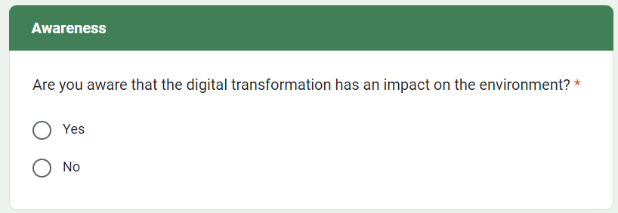

The majority of respondents (8 responses) indicated that they are aware of the environmental implications of the digital transition, while three respondents indicated that they were not. For those who replied that they were aware of the situation, they proceeded on to a new section asking for their opinions on the subject. For those who indicated they were unaware, they moved on to a new section containing some facts that would aid in their future awareness, and then they moved on to the same opinion section.

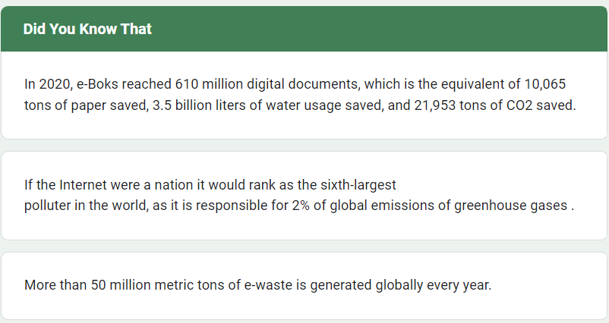

Awareness Section for thoes who answered “No”

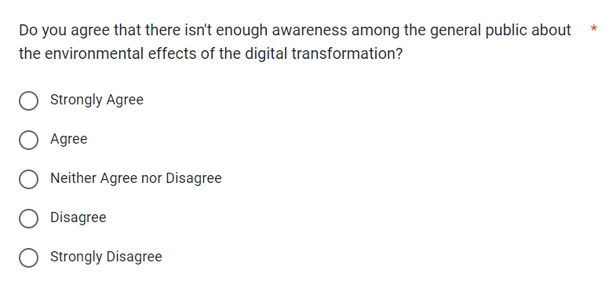The opinion section contains a total of 8 questions that mesure the level of awarness that the respondres have in regards with the environmental impact of digital transformation.

As seen above, 9 out of the respondents agreed or strongly agreed that the general public is not sufficiently aware of the environmental impact of the digital transformation, while the remaining 2 responders neither agreed nor disagreed. Ten out of the eleven respondents ranked their level of awareness as six or lower, with four choosing that ranking, one selecting five and another one selecting two, two selecting three, and two more selecting four. Out of the 11 respondents, only 1 rated their level of awareness as 8. Both questions collected quantitative data.

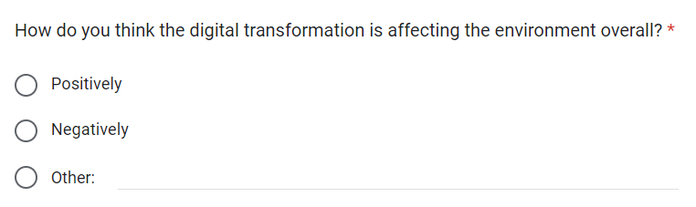

As can be seen above, 9 out of the respondents believed that the digital transformation had an overall negative impact on the environment, with just 2 believing the opposite. None of the respondents used the "Other" option, which was intended to allow qualitative data to be submitted if a person had another opinion.

The findings from gathering, organizing, and analyzing the qualitative data obtained from responses to this question regarding both positive and negative effects, were as follows.

By far, the majority of people (6 responses) believed that the energy consumption of datacenters, electronic devices, and the Internet had a negative impact on the environment. This was followed by the production of digital devices (3 responses), the extraction of raw materials (2 responses), and e-waste (2 responses).

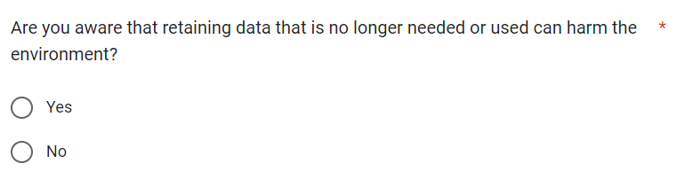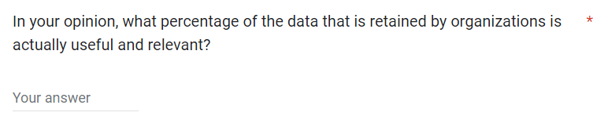Regarding the positives, two respondents believed that using digital documents instead of paper would be good for the environment. This was followed by the decrease in the number of trees being cut down (1 response), working from home to reduce office electricity use (1 response), and the fact that the digital transition has opened a brand-new world for us (1 response).

It appears that 7 out of all respondents are aware that data retention has some negative impact on the environment, whereas 4 respondents are apparently unaware of this. Additionally, it seems that respondents believe that between 40% and 83% of the data that organizations store is useful, with an average of 58.6% across all respondents.

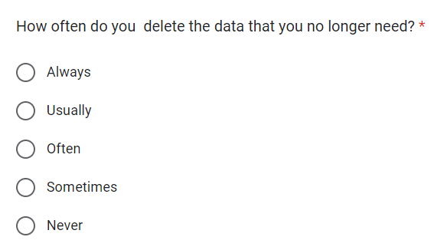

As can be seen above, seven respondents rarely erase any unnecessary data, 3 respondents often delete this data, and only 1 respondent usually does so, while no responders always or never delete this data. Regarding the recommendations made by the respondents, two of them proposed fewer datacenters, while another two suggested recycling e-waste and another two urged raising public awareness. One respondent suggested creating energy-efficient software, another suggested enforcing new laws and regulations to stop people from hoarding data, a third suggested relying more and more on renewable energy to power our digital devices and datacenters, and a fourth suggested providing practical advice to help people lower their digital carbon footprint.

**Secondary Data Analysis**Following the collection and analysis of the primary data obtained through the online survey, we began looking for and gathering secondary data from several sources, and the results are presented below.

Only 15% of organizations' data, according to the 2016 Global Databerg Report by Veritas Technologies, is deemed to be business crucial. As a result, 52% of all data that is processed and stored by businesses worldwide is categorized as Dark data, the value of which is unknown. The remaining 33% of the data are categorized as Redundant, Obsolete, or Trivial since they are regarded as being useless (ROT) (Veritas, 2016).

Because of a culture of "data hoarding" and disregard for retention policies, businesses are producing and storing data at record-breaking rates, leaving behind a massive carbon footprint unnecessarily. This data not only has an adverse effect on the environment, but it may also put a tremendous financial burden on these businesses, as the cost of maintaining non-critical data may cost a typical midsize company with 1000TB of data more than $650,000 a year (Veritas, 2016).

According to Aparavi, keeping ROT and Dark data can also increase the chances of security breaches. Breaches typically occur when you're unsure of exactly what data you have or where it is. This frequently happens, especially when staff members make their own copies of documents to take home in insecure file systems or on endpoints like PCs, USB sticks, or mobile phones, only to misplace them or have their equipment stolen, which exponentially raises the danger of a data breach. Legal settlements for data breaches may cost companies a significant amount of money (Aparavi, 2022).

Following the breach of its systems, Equifax agreed to a settlement for over one billion dollars. To make it simpler for staff members to access each other's data, some employees left a ROT data file containing all of the staff members' passwords, on the servers, which led to this incident (Aparavi, 2022).

Simply by deleting the ROT and Dark Data stored on your servers, it might save your firm many billions of dollars while also reducing the harmful environmental effects of the digital transformation.

**Conclusions Based on the Analysis**  
After completing the analyses of the primary and secondary data using charts as a method of data visualization and Microsoft Excel as a tool, the analysis suggests that there is a significant problem with people and organization's lack of awareness of the environmental impacts of the digital transformation, particularly with regards to the hoarding and retention of Dark and ROT data. This issue does not appear to be influenced by gender, age, organization, or position based on the primary data. Instead, it does appear that educational level does have an impact on this issue because both master's degree holders rated their level of awareness as a 6, with an average of 6, which is higher than the overall average of 4.8.

The analysis also revealed that while most individuals are aware of some of the negative environmental effects of the digital transformation, they are not aware of its entire scale or that keeping unnecessary data after they no longer need it could put them in unnecessary financial burdens. The analysis also revealed that most people are aware of how much energy datacenters use and that this problem needs to be resolved to reduce the negative environmental effects of the digital transformation. Finally, the analysis showed that the majority of people are aware that retaining data long after they need it has negative environmental impact, but most of them rarely do anything about it, and that they don’t realize that the vast majority of data that they keep is actually useless.

## **How the Research Theme Supports the Business Requirement**

Based on the analyses of both primary and secondary data, along with all the research that was conducted to complete this project, I concluded as follows. There is a fundamental problem with how people deal with data in general. People prefer to keep their data and hoard it rather than delete it, which causes both ROT and Dark data to accumulate over time as it reaches a point that this data accounts for 85% of all data saved. This behavior also reflects how corporations handle data retention, but the difference between them and average people, who may only have a few terabytes of data, is that organizations store many terabytes, petabytes, and in some cases, even exabytes of data. Keeping that much data causes pollution and a massive carbon footprint.

FutureTEC asked us to investigate the possibility of refurbishing, repairing, and reusing digital devices rather than replacing them in order to find solutions to reduce their environmental effect as a result of their digital transition. Using the project's initial concept, which is thoroughly explained on page5, we were able to achieve all of the aforementioned goals. The concept of reducing the environmental impact of digital transformation served as the foundation for the entire scheme. We were able to address all three points by repairing and refurbishing the servers before reuse again. In addition, we were able to recycle the leftover materials from the refurbishment rather than throwing them away as e-waste, which allowed us to meet all of the business requirements.

Although the project will cost thousands of dollars to implement and to buy the new technologies, it will ultimately save the corporation hundreds of thousands or perhaps even millions of dollars in addition to helping the environment. Additionally, by eliminating all ROT and Dark data, staff members will be able to use the organization's system more effectively, making it simpler and safer for them to access data, improving the quality of their job, their productivity, and cutting down on their time.

# ***Organizational Study***

## **The Features of the Organization**

Future Technology Systems Company - FutureTEC is an LLC company (Limited Liability Company) (ZoomInfo, 2017). An LLC is a particular kind of Private Limited Company (LTD) in the private sector that shields its owners from being held personally liable for any financial or legal liabilities that relate to their organization (Fernando, 2022b). Providing top-notch information security, information management, and business solutions, FutureTEC is a major provider of information technology solutions and a part of the quaternary industry (FutureTEC, 2020).

**The Operational Areas of the Organization**  
Business operations are all the procedures and tools that businesses employ to generate the best products and services with maximum efficiency, to increase the value of their company, and to make a profit. Business operations differ depending on the specifics of each firm and are subject to major change depending on the status of the market or economy (CFI, 2010). Some of the business functions in FutureTEC are:

* **Human Resources (HR):** it is the department in charge of managing all activities related to the organization's most vital resource, its employees. The HR department's main responsibility is to hire workers who are qualified for the numerous tasks that will be expected of them, to maintain a positive workplace culture that draws and keeps skilled workers, and to ensure that workers have all they need to carry out their daily jobs. In addition to hiring and firing staff, and providing compensation and benefits, this department's responsibilities also include increasing employee productivity and safeguarding the business from any problems that might emerge within the staff (Workable, 2021; Will Kenton, 2022). HR departments frequently make the mistake of concentrating on the financial expenses related to hiring employees, when their primary concern should be whether the candidates are a suitable fit for the jobs being filled. This is how FutureTEC hires its employees, and it is what sets their HR department apart from other HR departments.
* **Marketing:** it is the division in FutureTEC that is responsible for promoting its brand, products, and services. FutureTEC can grow and prosper to achieve their full potential and ROI with the aid of its superb marketing division. Since this division serves as the company's public face, its primary goals are to develop and manage the company's brand, attract new customers and investors, keep the website and social media platforms up to date, manage the company's online presence, and carry out a range of other responsibilities. As a result, the marketing team is the group responsible for bringing in new customers, keeping existing ones satisfied, and assisting Future TEC in expanding and achieving its organizational and financial objectives (The Hartford, 2019; Indeed Editorial Team, 2021; Wrike, 2022).
* **Customer Service:** itis a service that FutureTEC provides to help its customers by making their interactions with its services as easy and enjoyable as possible, both before and after they make a purchase. FutureTEC’s customer service goes beyond merely resolving customer complaints and completing requests, like most companies do, but rather it also entails providing customers with prompt support via the channel of their choice, whether it be through the phone, email, website, or any other means of communication. FutureTEC is very selective in the people it hires for its customer service departments because they are the primary point of contact between FutureTEC and its customers, thus even if customer service only deals with customers when necessary, those interactions are crucial to keeping the organization operating properly and keeping the customers satisfied (Amsler, 2020; Salesforce, 2022).

## **How do the Features and Operational Areas of the Organization Support its Purpose?**

FutureTEC can accomplish its goals in several ways with the aid of all the features and business operations stated above. First off, by providing excellent business operations, it can assist the company in drastically raising its productivity, in turn increasing sales and revenue. Better business operations also increase customer satisfaction, and happier customers tend to spend more money on the company's services, thus increasing their revenue even more. It also helps in creating an environment that is welcoming to growth and innovation which creates the infrastructure for innovation, thus fulfilling the organization’s purpose (Christiansen, 2021).

Additionally, having clear and specific organizational features can help customers, employees, and investors better understand the business. As a result, the business will draw in more customers, investors, and industry professionals, resulting in a highly skilled workforce, thus fulfilling the organization’s purpose as well.

By promoting this initiative and its benefits to the company's finances and environment, the marketing and sales department may aid FutureTEC in its success. Meanwhile, the customer service department can aid FutureTEC's clients by offering them whatever assistance they may need throughout this transition. Last but not least, the HR division can support FutureTEC's staff members by recruiting experts to train the company's personnel on the new system or by providing them with any assistance they require to implement this project in their business.

## **Stakeholders**

Any person or organization that is affected directly or indirectly by how a business operates or in the success or failure of the business is considered a stakeholder (Fernando, 2022a). The support of stakeholders is crucial for any project's success since a stakeholder's key responsibility is to provide their knowledge and perspective to a project in order to help the organization achieve its strategic goals and provide the necessary resources and supplies to them (MasterClass, 2022).

## **The Role of Internal Stakeholders**

The management, the staff, and the shareholders make up the internal stakeholders of FutureTEC. The success of the firm is of significant interest to these stakeholders because most of them have financial interests in the company due to their investments in it. Also, the internal stakeholders hold more power than external stakeholders, when it comes to decisions regarding the organization (Hill, 2019; Alva, 2021a).

* **Employees**: FutureTEC’s s ability to achieve its goals is significantly influenced by its employees, as they are the individuals who effectively contribute to the smooth operation of FutureTEC because they work diligently to produce their best work and complete the assigned tasks within the allotted time limit in order to ensure that they continue to be paid and keep their jobs (Management Study Guide, 2013; Alva, 2021a).
* **Mangers**: in addition to having a high degree of independence, high influence over their teams, and receiving a lot of support to carry out their duties, managers in FutureTEC are heavily focused on project management and how specific parts of the organization are operated (Alva, 2021a).
* **Shareholders**: since they are the company's owners and provide financial support in exchange for earnings, shareholders are keenly interested in strong performance of the organization because it will boost their investment returns (Pearse Trust, 2018; Alva, 2021a).

## **The Role of External Stakeholders**

Since external stakeholders typically do not participate in internal operations or decision-making of FutureTEC and do not have any personal or organizational financial investments in the company, they very rarely have the power to influence the direction of the business. Their primary function, in contrast to internal stakeholders, is to invest or stop investing in the business (Compliance Prime, 2019; Hill, 2019).

* **Suppliers:** they are individuals or organizations that provide products or services to FutureTEC and depend on the company for their revenue from the sale of those commodities to generate their own income. Suppliers frequently worry about the availability and safety of their goods and services because they directly impact how your company works (Active Campaign, 2022).
* **Customers:** they are the people or businesses who utilize FutureTEC’s services, making them the major stakeholders in determining whether the business succeeds or fails. Although customers are very loyal to the businesses they deal with, they also want to use the best service available, therefore, if the company fails to live up to their expectations, customers will just take their business elsewhere (Bitesize, 2020; Alva, 2021a).
* **Government Agencies:** they are organizations that want businesses follow the law, increase employment, and adhere to sound financial practices in order to support the economy. Additionally, the government must be seen as a proxy shareholder by any organization engaged in providing services to the public (Alva, 2021a; Kimberley, 2021).
* **Communities:** the actions, goals, traditions, mindset, and policies of the community can have an impact on businesses as the company can affect the communities directly. Communities view the company as a supplier of goods and services, a source of local employment, and a buyer of local materials (Glendinning, 2016; Alva, 2021a).

## **The Impact of Internal and External Stakeholders on the Success of the Organization**

All internal and external stakeholders contribute to the success of FutureTEC, one way or the other. For example, employees contribute to the success of the company by carrying out the tasks they were hired to do with the highest levels seriousness, attention, honesty, and dedication, and by following the instructions given by their employer (Éducaloi, 2021). It should go without saying that the success of the organization will eventually result from each stakeholder being able to fulfill their responsibilities.

For instance, managers in FutureTEC contribute to the success of the company every day, by making important commercial and operational decisions in an effort to accomplish the goals and objectives set forth by shareholders and owners. At the same time, shareholders support the company's success by deciding on FutureTEC's operations and offer financing to help the company launch and expand, while suppliers have an impact on FutureTEC's success by ensuring that the company receives the desired quality and quantity of goods and services on schedule. The government may help FutureTEC succeed by decreasing taxes or by allowing them enough time to adjust to any new changes in legislation. Local communities and customers can contribute to the success of FutureTEC by using its goods and services and encouraging other organization to use FutureTEC’s services (BBC Bitesize, 2020).

A company wouldn't be able to function without its stakeholders, and stakeholders have an impact on how and why a company conducts its business. However, not all stakeholders are created equal because different stakeholder groups have different responsibilities and levels of influence over how an organization is run (Alva, 2021b).

Regardless of whether they were internal or external stakeholders, their in-depth knowledge of current procedures, background information, business insights, and their experience in the field can be very beneficial to the success of the company. It's possible that some of them know more about the organization or the project than the project manager does. Due to their knowledge and experience, combined with increased involvement and engagement from them, they may be able to assist the business in identifying and minimizing some of its risks. Additionally, by including stakeholders early on, you can get their advice on how to gradually enhance your company, which will guarantee project approval and produce better results (Schoenhard, 2019).

**Challenges to the Success of the Organization**  
There are several challenges that FutureTEC faces regularly, some of them include:

* **Legislation and industry standards relevant to FutureTEC:** the government uses the law to control companies’ activities and stop it from exploiting individuals, protecting both customers who deals with companies and the employees who work for them. These laws have several effects on businesses, including (BBC Bitesiz, 2020):

1. **Costs and Profits**: legislations can have a significant impact on FutureTEC’s finances, and they can be a double-edged sword in that they can either boost revenues or end up costing the company thousands of dollars. Following regulations and industry standards, for instance, will improve a company's reputation and brand image while also creating a safe and ethical workplace that will increase sales for the business drastically. On the other side, mandating that FutureTEC trains their staff, do routine safety inspections, pay taxes, and attain the minimum wage of salaries could end up costing the company thousands of dollars, driving their profits down.
2. **Marketing and Sales:** enforcing laws on FutureTEC could have a range of effects on marketing and sales. Legislations, for instance, could cause increased sales, ensure a good brand image, lower the risk of customer lawsuits, and reduce the likelihood of brand replication by other businesses. On the other hand, abiding by all rules might be expensive, which makes sales more important. Additionally, any problems with the items could have a negative effect on sales, and the branding, and intellectual property must be original.
3. **Production:** providing high-quality products and a health workplace may increase sales, boost consumer confidence, and increase employee productivity, all of which may increase the FutureTEC’s overall quality of services. This is accomplished through laws that regulate the level of quality of products and the working conditions of businesses. Enforcing these laws may be expensive because all goods and services must be produced to satisfactory standards by using high-quality materials, and productivity may be negatively impacted by complying with working-time requirements.
4. **Human Resource Act:** legislation that supports the human resource act can ensure lower staff turnover, lower hiring expenses, less complaints, and happier employees, all of which increase the FutureTEC’s productivity. However, making sure that all legal standards are followed can be costly, and if mistakes are made, costly legal action may follow.

* **Change Management:** whether they be tiny staff reorganizations or significant mergers, everyone is affected by changes, as they are necessary for any firm to succeed in a highly competitive market. It is common to experience significant resistance to these changes, but by keeping the team informed and up to date, you can greatly smooth the transition and reduce the resistance. If you don't, it could result in decreased productivity and job satisfaction due to their lack of involvement in the change, which would result in resistance to change (Smith, 2018). There are two types of changes:

1. **Planned Changes:** it i**s** the procedure for preparing the workforce of the FutureTEC for a new direction whenever it is needed. This strategy can be used to improve the company's culture, internal structures, procedures, measurements, rewards, and other elements (Pop, 2018). Examples of planned changes include:
2. **Expansion:** most businesses will ultimately face, and even FutureTEC faced the opportunity of business growth and development. This step is very critical for any business as it is full of opportunities and dangers, because if it is managed properly, it can raise the company’s revenue exponentially, otherwise, the results can be catastrophic to the business (Verde, 2021).
3. **Diversification:** it is a planned strategy whereby a company concentrates on multiple industries at once to offer a number of various products or services that are not necessarily related to one another in order to benefit their current customer base, a comparable market, or an altogether different audience. FutureTEC implements diversification by delivering world-class information security, information management, and business solutions. (Knowledge Center, 2019).
4. **Changes in Legislation:** most governmental law changes are outside of the control of businesses; nonetheless, these alterations must be made known to businesses before they go into effect, giving them adequate time to plan and take any necessary activities to guarantee that they abide by the new requirements. Failure to do so could have serious consequences, such as fines or jail time, as well as bad press that might have a negative effect on sales (BBC Bitesiz, 2021).
5. **System Upgrades:** when upgrading to a new system in the organization, it can come with a variety of challenges associated with the cost of the installation of the new system, the staff’s ability to adapt to the new system, and it could take some time until the organization finds a systems that is suitable to their organization, and unfortunately some data may be lost during the migration to the new system. This is one of the main challenges that FutureTEC will face when implementing the project as they need a new system to minimize data retention, and FutureTEC is planning to minimize the effect of upgrading to a new system (Merrill, 2019).
6. **Unplanned Changes:** it is changes that happen in an organization that was not anticipated before it was required, frequently as a result of changes in the environment in which it operates (Mahauganee Shaw, 2018). There are two types of unplanned change:
7. **Internal:** it is the change that occurs within a company without prior planning and is implemented hastily. Often, internal unplanned changes occur in FutureTEC, as they might arise as a result of a shift in the demographic composition of the company, such as what happens when individuals previously excluded from certain jobs are now able to perform them normally. These changes in the demographics can happen very rapidly and business have to adapt quickly to them. Another reason for unplanned internal changes could be performance gaps. For instance, when a new product or service doesn't perform as well as anticipated, they may need to make urgent adjustments to close the gap. Performance gaps serve as catalysts for organizational innovation, according to research (Juneja, 2017).
8. **External:** organizations are forced to change as a result of two very important factors: economic uncertainty and changes in governmental rules. FutureTEC faces this problem like any other organization because this can happen when the government changes some of its legislations and it doesn’t give businesses enough time to adapt to the new regulations. Also, due to competitive constraints brought on by the global economic environment, organizations are forced to rapidly and continually change according to the market’s need to gain more clients, therefore, increase their revenue.

**Organization Requirements**  
These contain all the prerequisites that the organization must meet before the project can start.

* + **Cost:** the cost for this project mainly consists of the intelligent data management platforms that will be used to filter out all the existing data and the new system that implements new policies for data retention across the company’s entire system.
  + **Scope:** the scope of the project will be the elimination of all the ROT and Dark data across the entire system and prevent their retention.
  + **Time:** time is of the essence because holding onto ROT and Dark data costs FutureTEC hundreds of dollars daily and has a significant negative impact on the environment. However, FutureTEC shouldn't rush the project as it should only start off after all the organization's requirements have been satisfied. The project should be finished in about three months.
  + **Quality:** to ensure that the new system suits the organization’s requirements, this can be done by testing the system on a small part of the company’s data and checking whether it eliminated all ROT and Dark data or not, and if it removed any organizational essential data or not. If it met the organization’s needs, then the system will be of high quality.
  + **New Technologies (Resources):** as noted in the cost section, this project also needs a new data retention system to enforce regulations against hoarding data, as well as an intelligent data management platform to help filter out all the existing data.
  + **Planned Change Management:** employees should be trained on the new system prior to its installation on the entire system to ensure that the business continues its operation smoothly right after the new system has been implemented, to maximize employees’ engagement, and minimize their resistance to change.
  + **Communication:** FutureTEC should regularly and clearly communicate with its stakeholders and sponsors, in order to make sure that the system meets their expectations and is being implemented in a manner they deem appropriate.

# ***References***

ACT (2022) *5 Environmental Benefits of Minimalism, ACT.* Available at: <https://www.sortitoutsustainably.com/blog/the-5-environmental-benefits-of-minimalism>

Active Campaign (2022) *The 10 Types of Stakeholders That You Meet in Business, Active Campaign.* Available at: [https://www.activecampaign.com/blog/types-of-stakeholders](https://www.activecampaign.com/blog/types-of-stakeholders%20)

Alva (2021a) *Types of stakeholders and their role in the company, Alva Group.* Available at: [https://www.alva-group.com/blog/types-of-stakeholders-and-their-role-in-the-company/](https://www.alva-group.com/blog/types-of-stakeholders-and-their-role-in-the-company/%20)

Alva (2021b) *What are the impacts of stakeholders on a business?, Alva Group.* Available at: [https://www.alva-group.com/blog/what-are-the-impacts-of-stakeholders-on-a-business/](https://www.alva-group.com/blog/what-are-the-impacts-of-stakeholders-on-a-business/%20)

Amsler, S. (2020) *What are Customer Service and Customer Support?, TechTarget.* Available at: [https://www.techtarget.com/searchcustomerexperience/definition/customer-service-and-support](https://www.techtarget.com/searchcustomerexperience/definition/customer-service-and-support%20)

Aparavi (2022) *ROT and Dark Data: Examples of 5 Types of Hidden Costs, Aparavi.* Available at: <https://www.aparavi.com/resources-blog/rot-dark-data-costs>

BBC Bitesiz (2020) *The need for legislation in business - The impact of legislation on businesses*, *BBC Bitesize*. Available at: <https://www.bbc.co.uk/bitesize/guides/z49xxyc/revision/1>

BBC Bitesiz (2021) *Businesses’ responses to changes in legislation*, *BBC Bitesize*. Available at: <https://www.bbc.co.uk/bitesize/guides/zdxynrd/revision/2>

BBC Bitesize (2020) *How stakeholders influence business activity and business decisions - Business aims and objectives*, *BBC Bitesize*. Available at: <https://www.bbc.co.uk/bitesize/guides/zvhrrj6/revision/6.>

Bitesize (2020) *Owners/shareholders - Stakeholders - Higher Business management Revision*, *Bitesize*. Available at: [https://www.bbc.co.uk/bitesize/guides/znf7nrd/revision/10%0A](https://www.bbc.co.uk/bitesize/guides/znf7nrd/revision/10%0Ahttps://www.bbc.co.uk/bitesize/guides/znf7nrd/revision/2)

CFI (2010) *Business Operations - Overview, Examples, How To Improve, CFI.* Available at: [https://corporatefinanceinstitute.com/resources/knowledge/strategy/business-operations/](https://corporatefinanceinstitute.com/resources/knowledge/strategy/business-operations/%20)

Christiansen, L. (2021) *Building an Understanding of Business OperationsMenu, Altametrics.* Available at: <https://altametrics.com/business-operations.html>

Compliance Prime (2019) *Role of Stakeholders in Business Organization - Compliance Prime Blog, Compliance Prime.* Available at: [https://www.complianceprime.com/blog/2019/10/17/role-of-stakeholders-in-business-organization/](https://www.complianceprime.com/blog/2019/10/17/role-of-stakeholders-in-business-organization/%20)

Éducaloi (2021) *Rights and Responsibilities of Employers and Employees | Éducaloi, Éducaloi.* Available at: <https://educaloi.qc.ca/en/capsules/rights-and-responsibilities-of-employers-and-employees/>

Fernando, J. (2022a) *What Are Stakeholders: Definition, Types, and Examples*, *Investopedia*. Available at: <https://www.investopedia.com/terms/s/stakeholder.asp>

Fernando, J. (2022b) *What is an LLC? Limited Liability Company Structure and Benefits Defined*, *Investopedia*. Available at: <https://www.investopedia.com/terms/l/llc.asp>

FutureTEC (2020) *About us – Futuretec, FutureTEC.* Available at: <https://futuretec.me/about-us/>

Gartner Glossary (2021) *Definition of Dark Data, Gartner Glossary.* Available at: <https://www.gartner.com/en/information-technology/glossary/dark-data>

Glendinning, R. (2016) *Community Stakeholders, Neighboring Economics.* Available at: <http://neighborhoodeconomics.org/community-stakeholders/>

Hill, B. (2019) *What Are the Stakeholders’ Roles in a Company?, Chron.com.* Available at: <http://smallbusiness.chron.com/stakeholders-roles-company-25029.html>

Indeed Editorial Team (2021) *What Does a Marketing Department Do? (With Benefits and Tools) | Indeed.com, Indeed.* Available at: <https://www.indeed.com/career-advice/career-development/what-does-a-marketing-department-do>

Juneja, P. (2017) *Forces of Organizational Change: Planned vs. Unplanned Change and Internal & External Change, Management Study Guide.* Available at: <https://managementstudyguide.com/forces-of-organizational-change.htm>

Kimberley (2021) *How Identify and Engage with Government Stakeholders, Swift Digital.* Available at[: https://www.swiftdigital.com.au/blog/government-stakeholders/#:~:text=Government is an important stakeholder,critical to long term success.](:%20https:/www.swiftdigital.com.au/blog/government-stakeholders/%23:~:text=Government%20is%20an%20important%20stakeholder,critical%20to%20long%20term%20success.)

Knowledge Center (2019) *Addressing the benefits of business diversification, Knowledge Center.* Available at: <https://marketfinance.com/business-finance/why-you-should-consider-diversifying>

Mahauganee Shaw (2018) *Unplanned Change and Crisis Management | SpringerLink, SpringerLink.* Available at: <https://link.springer.com/referenceworkentry/10.1007%2F978-3-319-20928-9_748>

Management Study Guide (2013) *Role of Employees in Organization Culture, Management Study Guide.* Available at: <http://www.managementstudyguide.com/role-of-employees-in-organization-culture.htm>

MasterClass (2022) *Stakeholder Definition and Examples*, *MasterClass*. Available at: <https://www.masterclass.com/articles/stakeholder-explained>

Merrill, C. (2019) *10 Challenges To Think About When Upgrading From Legacy Systems, Zibtek Blog.* Available at: <https://www.zibtek.com/blog/10-challenges-to-think-about-when-upgrading-from-legacy-systems/>

Pearse Trust (2018) *Roles & Responsibilities Of A Company Shareholder, Pearse Trust.* Available at: <https://www.pearse-trust.ie/blog/roles-responsibilities-of-company-shareholder>

Pop, O.-M. (2018) *Planned Change Management and Why You Should Care, HYPE Innovation Blog.* Available at: <https://blog.hypeinnovation.com/planned-change-management>

Robinson, P. (2021) *What is ROT (Redundant, Obsolete, and Trivial) Data and How to Manage It, Lepide.* Available at: <https://www.lepide.com/blog/what-is-rot-data-and-how-to-manage-it/>

Salesforce (2022) *What Is Customer Service?, Salesforce.* Available at: <https://www.salesforce.com/resources/articles/what-is-customer-service/>

Schoenhard, L. (2019) *4 Ways Stakeholders are Important to a Project, Proficient Learning, LLC.* Available at: <https://proficientlearning.com/4-ways-stakeholders-are-important-to-a-project/>

Smith, C. (2018) *What are the challenges faced during organizational change management?, Walk me.* Available at: <https://change.walkme.com/organizational-change-management/>

Thales (2022) *The Benefits of Digital Transformation*, *Thales Group*. Available at: <https://cpl.thalesgroup.com/software-monetization/benefits-of-digital-transformation>

The Hartford (2019) *The Role of a Marketing Department in a Business, The Hartford.* Available at: <https://www.thehartford.com/business-insurance/strategy/creating-marketing-department/role>

Thew, A. (2020) *The Carbon impact of the Internet, Green Element.* Available at: <https://www.greenelement.co.uk/blog/the-carbon-impact-of-the-internet/>

Truong, T.C. (2022) *‘The Impact of Digital Transformation on Environmental Sustainability’, Advances in Multimedia, 2022.* Available at: <https://doi.org/10.1155/2022/6324325>

UNEP (2022) *Digital Transformation, UNEP.* Available at: <https://www.unep.org/explore-topics/technology/what-we-do/digital-transformation>

Velazco, C. (2021) *Here’s how to repurpose and recycle your old technology, The Washington Post.* Available at: <https://www.washingtonpost.com/technology/2021/09/28/how-to-recycle-repurpose-e-waste/>

Verde, G. (2021) *The 6 Best Strategies For Business Expansion, NNRoad.* Available at: <https://nnroad.com/blog/business-expansion-strategies/>

Veritas (2016) *Veritas Global Databerg Report Finds 85% of Stored Data Is Either Dark, or Redundant, Obsolete, or Trivial, Veritas.* Available at: <https://www.veritas.com/news-releases/2016-03-15-veritas-global-databerg-report-finds-85-percent-of-stored-data>

Whatfix (2021) *What is Digital Transformation? Overview, Why and How, Whatfix.* Available at: <https://whatfix.com/digital-transformation/>

Will Kenton (2022) *Human Resources (HR) Meaning and Responsibilities, Investopedia.* Available at: <https://www.investopedia.com/terms/h/humanresources.asp>

Workable (2021) *What is Human Resources (HR)? [definition and more], Workable.* Available at: <https://resources.workable.com/hr-terms/human-resources-definition>

Wrike (2022) *Building a Marketing Department & Team, Wrike Inc.* Available at: <https://www.wrike.com/marketing-guide/marketing-team-department/>

ZoomInfo (2017) *FutureTec Group - Overview, News & Competitors, ZoomInfo.* Available at: <https://www.zoominfo.com/c/futuretec-group-llc/425728637>